9100 Series Sanitary Seal

USDA, AMS Accepted
Meat & Poultry Equipment

Compliant with NSF/ANSI/3-A 14159-1-2002
9100系列卫生密封
USDA和AMS批准肉禽类设备
符合NSF/ANSI/3-A 14159-1-2002

USDA Acceptance of 9100 Series Seal
USDA批准9100系列密封

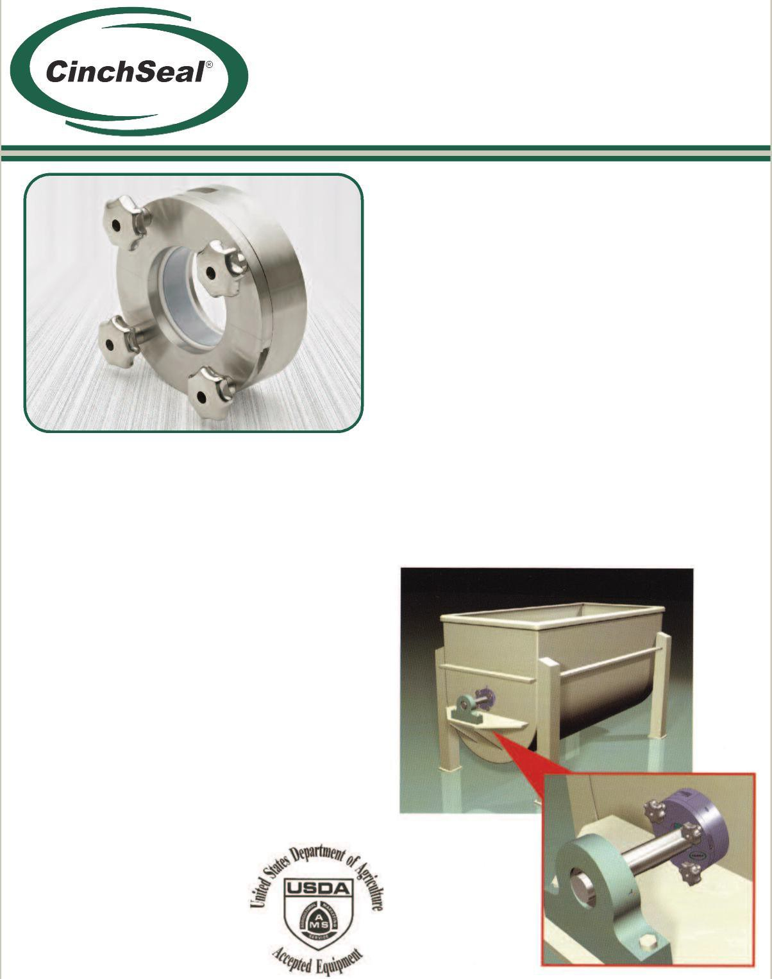

Knobs are quoted separately.旋钮单独报价。

Seal installation requires no removal of bearings or drive units due to split design
• ● 由于剖分式设计，密封安装无要拆卸轴承或传动装置
- Stops product leaks and eliminates housekeeping issues
- 避免产品泄漏，消除维护管理问题
- No mechanical adjustments needed once installed
- 安装后无需机械调整
- Does not damage shafts like lip seals and packing
- 不会损坏轴，与唇形密封和填料不同
- Machined from stainless steel to accommodate caustic washdowns
- 由不锈钢加工而成，可进行碱洗
- Eliminates batch contamination
- 消除批量污染
- Seal can easily be disassembled and assembled for wash downs between batches
- 密封易于拆卸和组装，方便批量冲洗
February 22, 2010 - The United States Department of Agriculture, Marketing and Regulatory Programs, Agricultural Marketing Service has awarded an Equipment Acceptance Certificate to Cinchseal® for its new 9100 Series Seal. The new seal is in compliance with NSF/ANSI/3-A 14159-1 - 2002 Hygiene requirements for the design of meat and poultry processing equipment. The 9100 model designation is for a split mechanical rotary seal. For more information about the 9100 series seal, please contact Cinchseal® directly at 856-662-5162.
2010年2月22日—美国农业、营销和监管项目部和农业营销服务部授予辛驰密封新的9100系列密封设备验收证书。新密封符合NSF/ANSI/3-A 14159-1-2002肉类和家禽加工设备设计卫生要求。9100型号设计为剖分式机械旋转密封。有关9100系列密封的更多信息，请直接致电856-662-5162与辛驰密封联系。

CinchSeal • 731 Hylton Road • Pennsauken, NJ • 08110
856.662.5162 • 856.662.5264 • www.cinchseal.
辛驰密封• 新泽西州彭索肯郡市 • 希尔顿路731号 • 08110
856.662.5162 • 856.662.5264 • www.cinchseal.

Exploded view of CinchSeal 9100 Series  9100系列分解图  Split Stainless Steel Housing剖分式不锈钢外壳  Split Elastomer Boot剖分式弹性体防尘套  Split PTFE Rotor Cups剖分式PTFE转子杯  Split Stainless Plate剖分式不锈钢板 | How the 9100 Series Works  9100系列的工作原理  The heart of our USDA approved 9100 seal is our elastomer “boot” that is designed to create an interference fit on the shaft. This tight fit allows the elastomer to turn with the shaft and thereby eliminating shaft damage or wear. The elastomer “boot” seals the shaft and stops product from migrating past while also turning a series of mineral filled PTFE rotor cups. As the elastomer and rotor cups turn with the shaft they are compressed with the optimum amount of face pressure against a stationary face. The rotating face against a stationary face is what creates the primary seal that stops product from getting by. The PTFE rotor cups are designed to be the wearable part of the seal and repair kits are available. The repair kit consists of two new PTFE split rotor cups and new split elastomer. The seal is designed to be purged with air 5 to 8 PSI over vessel pressure to keep rotating seal faces cool and free of material. The 9100 seal is easy to take apart, clean, and re-assemble for daily maintenance.  辛驰密封9100系列的核心部件是由美国农业部批准的弹性体“防尘套”，与轴过盈配合。这种紧密配合使弹性体随轴一起旋转，避免轴损伤或磨损。弹性体“防尘套”不但起到密封作用，防止产品迁移，同时带动一系列矿物填充的PTFE转子杯。当弹性体和转子杯随轴旋转时，它们会以最佳表面压力挤压固定面，旋转面和固定面之间形成主密封面，防止产品泄露。PTFE转子杯设计为密封磨损部件，配备维修包。维修包会包含两个新的PTFE剖分式转子杯和新的剖分式弹性体。密封可通入高于容器内部压力 5到8PSI的空气净化，降低旋转面温度，吹落表面材料。9100密封易于安装、清洗或重新组装，便于日常维护。
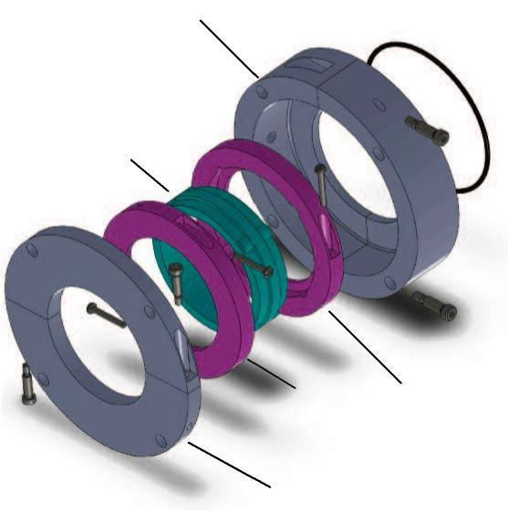Applications应用 Available Accessories配件
Greaser
Automatic
•
Regulators
Air Pressure
•
Seal Repair Kits
•
The CinchSeal 9100 series is designed to seal rotating shafts on meat blenders and cookers used in the meat and poultry processing industry. It can also be used on ribbon blenders and paddle mixers used in processing dry powder, semi-solid, and slurry applications.
辛驰密封9100系列适用于肉类和家禽加工行业中肉类搅拌机和炊具的旋转轴密封。也可以用于处理干粉、半固体和浆料产品的螺条搅拌机和浆式搅拌机。
Purge Options清洗选项 Installation安装
●维修密封包

●空气调节阀

●自动润滑器

All CinchSeals should be purged with either plant air, nitrogen, or silicone grease. For best results, each seal should have an individual air regulator and not share. Air purging the seal creates a higher pressure inside the seal cavity which creates an air barrier that helps keep material inside the tank and out of the seal which adds to the life of the wearable parts of the seal.
所有辛驰密封都应该通入工厂空气、氮气净化，或使用硅脂清洗。为了达到最佳效果，每个密封应该使用单独的空气调节器，而不是共用一个。空气净化会在密封腔内产生更高的压力，从而形成气密层，使材料保持在容器内、密封外，从而增加密封磨损件的寿命。
The CinchSeal 9100 series should not be installed on severely worn equipment. Damaged shafts or excessive float or misalignment should be corrected prior to installation. The seal must be mounted square to the shaft. Please refer to installation guide when mounting your seal.
辛驰密封9100系列不应安装在磨损严重的设备上。应在安装前更换损坏轴或纠正过度不对中。密封必须与轴垂直安装。安装密封时请参阅安装指南。

