**Solid Housing**

**实心外壳**

**Solid PTFE Rotor Cups**

**实心PTFE转子杯**

**CinchSeal • 731 Hylton Road • Pennsauken, NJ • 08110 856.662.5162 • 856.662.5264 • [www.cinchseal.com](http://www.cinchseal.com)**

**辛驰密封• 新泽西州彭索肯郡市 • 希尔顿路731号 • 08110**

**856.662.5162 • 856.662.5264 • [www.cinchseal.com](http://www.cinchseal.com)**

* Designed to replace rope packing on rotary air locks
* 用于替代旋转气锁上的绳索填料
* Zero maintenance due to self-adjusting design
* 其自调校设计可实现零维护
* Custom seal housings available in Aluminum and SS
* 自定义密封外壳可选铝和不锈钢两种
* Seals can be rebuilt with inexpensive repair kits
* 密封件可使用价格低廉的维修包重新组装
* Designed to handle 1/4” total radial shaft runout
* 设计可承受1/4”总径向跳动
* Designed to be air purged at 7 PSI over vessel pressure
* 通入高于设备内部压力7PSI的空气净化
* Designed for temperature ranges -50F to 400F
* 设计工作温度范围为-50F到400F

**Cover Plate**

**盖板**

**Rotary Air Lock Seal**

**旋转气锁密封**

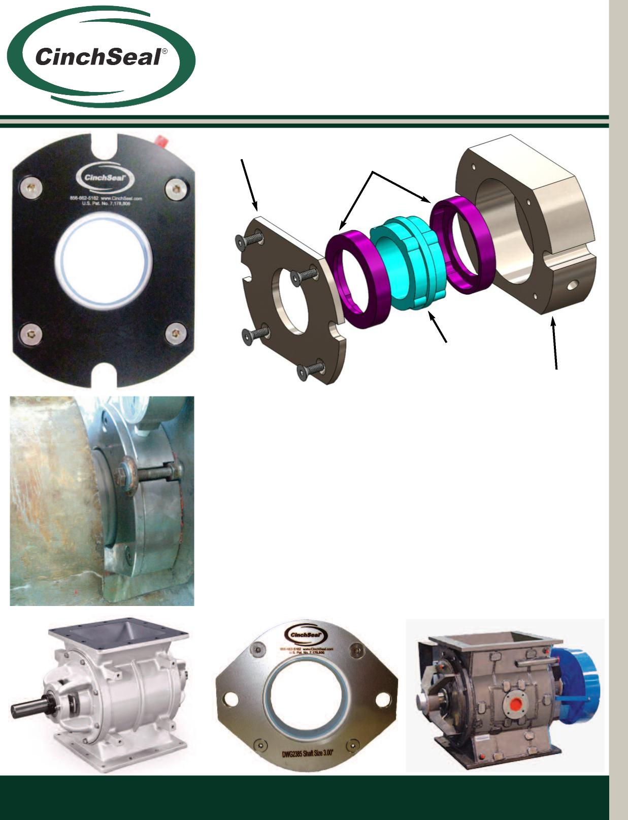

**Solid Boot**

**实心防尘套**