- Shaft damage and wear is totally eliminated due to the unique elastomer design that turns with the shaft
- 独特的随轴转动的弹性体设计，彻底消除轴损伤和磨损

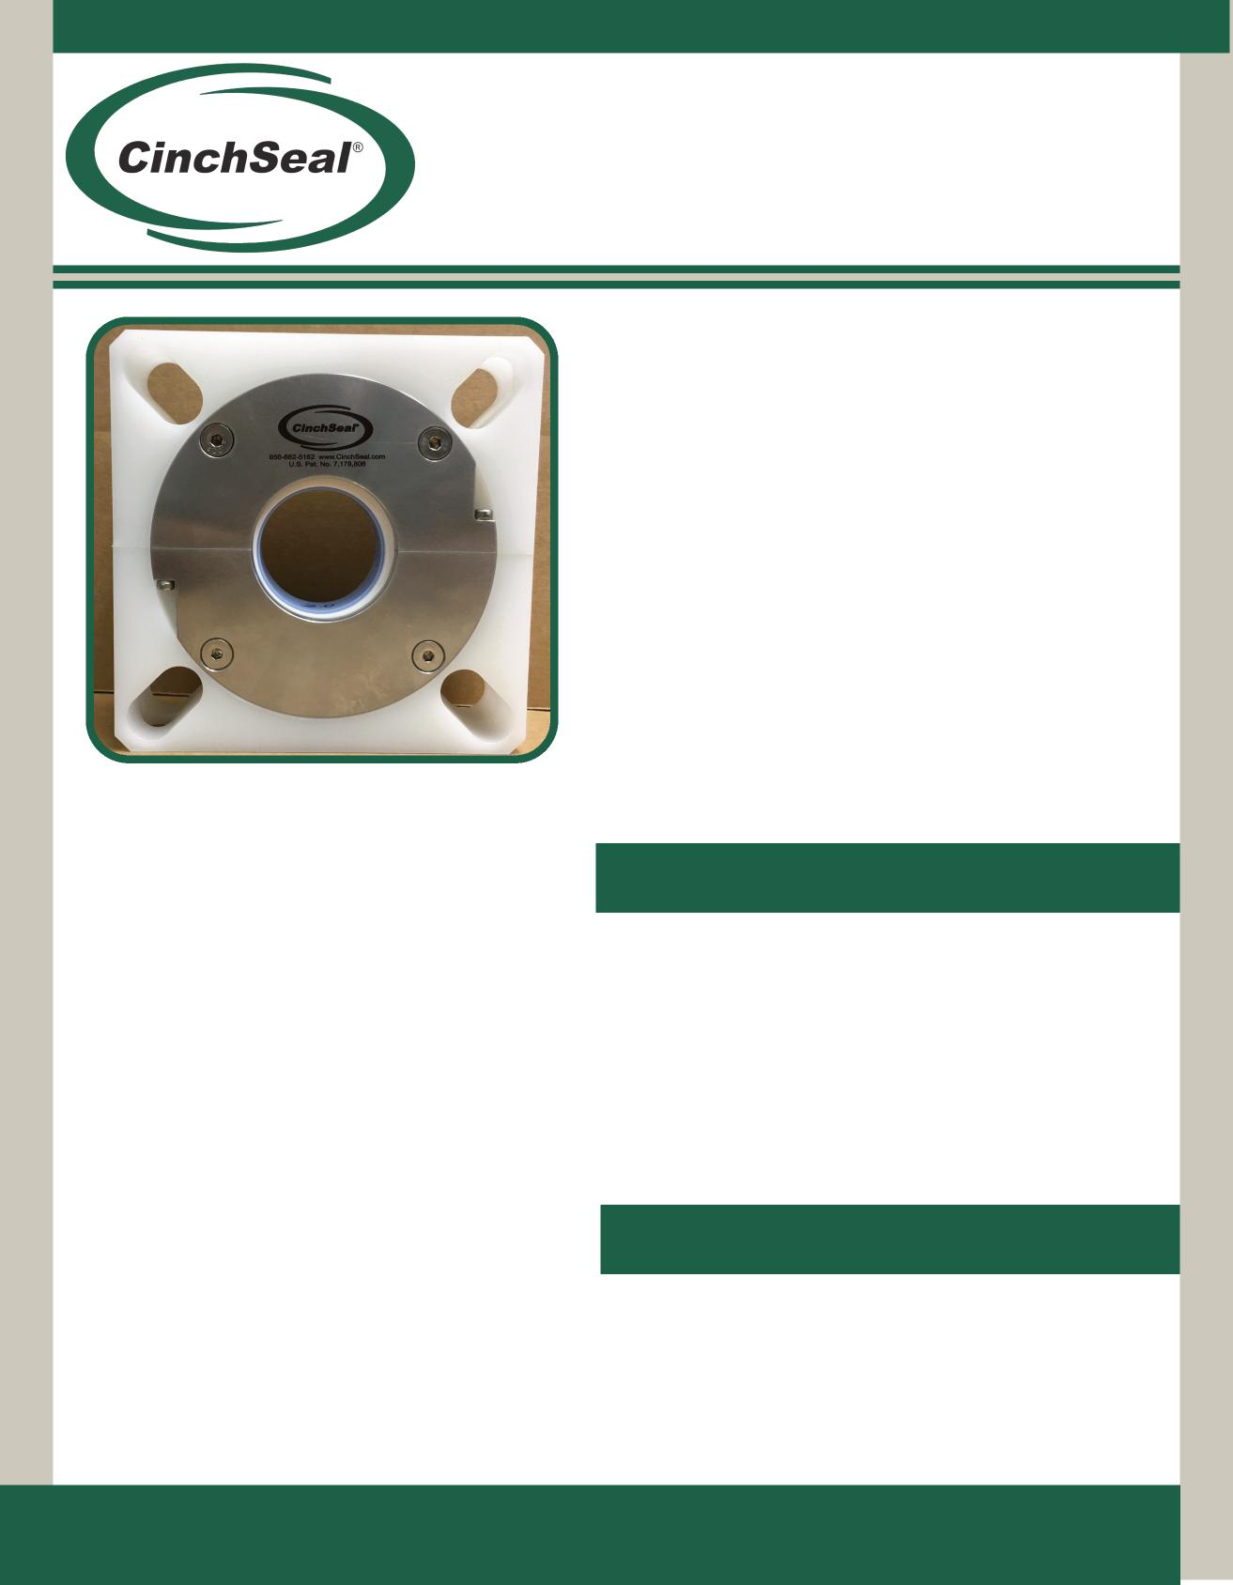
Poly Split (PS) Shaft Seal
聚乙烯剖分式（PS）轴封
Machined entirely split to make
installation a Cinch...完全剖分式，使安装成为辛驰…
The model PS CinchSeal® is designed to seal screw conveyors, mixing and blending equipment. It is manufactured out of polypoplene and stainless steel to handle dry powder and slurry products in the food service, pharmaceutical and chemical industries where stainless steel is required.
辛驰密封PS型号是专用于螺旋输送机、搅拌和混合设备的密封。它由聚丙烯和不锈钢制成，用于处理食品服务、制药和化工等行业中需要使用不锈钢的干粉和浆料产品。
Applications应用
- Eliminates product leakage, house keeping issues, bearing and drive failure
- 消除产品泄漏、维护管理问题、轴承和驱动故障
- Installation requires no equipment removal
- 安装无需拆卸设备
The PS CinchSeal is proven effective in sealing ribbon blenders, driers, and paddle mixers used in processing dry powder, semi-solid and slurry applications. Among the particularly challenging materials we have been successful in sealing are: cement, spices, cocoa powder, liquid chocolate, plastics and resins, salt, sugar, etc.
事实证明，辛驰密封PS型号是螺条搅拌机、干燥机、浆式搅拌机的有效密封，用于处理干粉、半固态和浆料产品。我们已经成功运用到特别具有挑战性的材料中：水泥、香料、可可粉、液体巧克力、塑料和树脂、盐、糖等。
- Eliminates product contamination caused by the breaking down of braided packing
- 消除编织填料破裂造成的产品污染
- Seals hazardous vapors and dust
- 密封有害蒸汽和粉尘
- Consumes less power than braided packing
- 比编织填料的耗能少
- Will not damage or undercut shaft
- 不会损坏或削弱轴
- Seal Repair Kits
- 密封维修包
- Air Pressure Regulators
- 空气调节阀
- Additional Elastomers
- 附加弹性体
Available Accessories配件
CinchSeal • 23b Roland Avenue • Mount Laurel, NJ • 08054 856.662.5162 • 856.662.5264 • www.cinchseal.com
辛驰密封• 新泽西州月桂山市• 罗德大道23b号 • 08054 856.662.5162 • 856.662.5264 • www.cinchseal.com

Exploded view of CinchSeal Poly Split PS型号分解图

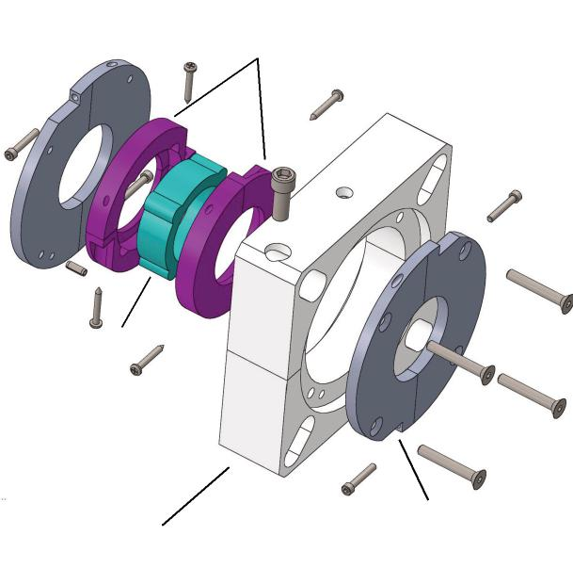
Elastomer Boot
弹性体防尘套
Split Poly Housing
剖分式聚乙烯外壳
Stainless Plate
不锈钢板

Installation安装
How the Poly Split Works
Split PTFE Rotor Cups
剖分式PTFE转子杯
PS型号工作原理
The heart of the PS CinchSeal is the FDA approved elastomer which is designed to create an interference fit on the shaft. This tight fit allows the elastomer to turn with the shaft and thereby eliminating shaft damage or wear. The elastomer seals the shaft and stops product from migrating past while also turning a set of mineral filled PTFE rotor cups. As the elastomer and rotor cups turn with the shaft they are compressed with the optimum amount of face pressure against a stationary face. The rotating face against a stationary face is what creates the primary seal that stops product from getting by. The PTFE rotor cups are designed to be the wearable part of the seal and repair kits are available. The repair kit consists of two new PTFE split rotor cups and new split elastomer. The seal is designed to be purged with air 5 to 8 PSI over vessel pressure to keep rotating seal faces cool and free of material. The PS seal is easy to take apart, clean, and re-assemble for daily maintenance.
辛驰密封PS型号的核心部件是由美国食品及药物管理局批准的弹性体，与轴过盈配合。这种紧密配合使弹性体随轴一起旋转，避免轴损伤或磨损。弹性体不但起到密封作用，防止产品迁移，同时带动矿物填充的PTFE转子杯。当弹性体和转子杯随轴旋转时，它们会以最佳表面压力挤压固定面，旋转面和固定面之间形成主密封面，防止产品泄露。PTFE转子杯设计为密封磨损部件，配备维修包。维修包会包含两个新的PTFE剖分式转子杯和新的弹性体。密封可通入高于容器内部压力 5到8PSI的空气净化，降低旋转面温度，吹落表面材料。PS密封易于安装、清洗或重新组装，便于日常维护。

The PS CinchSeal should not be installed on severely worn equipment. Damaged shafts or excessive float or misalignment should be corrected prior to installation. The seal must be mounted square to the shaft. Please refer to installation guide when mounting your seal. Call or visit our website if help is needed.
辛驰密封PS型号不应安装在磨损严重的设备上。应在安装前更换损坏轴或纠正过度不对中。密封必须与轴垂直安装。安装密封时请参阅安装指南。如有需要，请致电或浏览我们的网站。
Purge Options清洗选项
All CinchSeals should be purged with either plant air, nitrogen, or silicone grease. For best results, each seal should have an individual air regulator and not share. Air purging the seal creates a higher pressure inside the seal cavity which creates an air barrier that helps keep material inside the tank and out of the seal which adds to the life of the wearable parts of the seal.
所有辛驰密封都应该通入工厂空气、氮气净化，或使用硅脂清洗。为了达到最佳效果，每个密封应该使用单独的空气调节器，而不是共用一个。空气净化会在密封腔内产生更高的压力，从而形成气密层，使材料保持在容器内、密封外，从而增加密封磨损件的寿命。
Poly Split Assembly Drawing
PS型号部件图
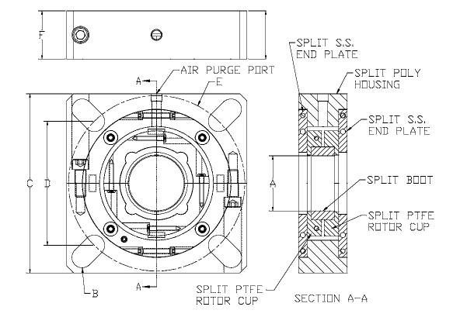
Dimensional Chart尺寸图表
A | B | C | D  min | D  max | E  min | E  max | F
1.5 | .625 | 5.375 | 3.30 | 4.375 | 4.709 | 6.162 | 1.75
2.0 | .750 | 6.50 | 4.0 | 5.386 | 6.657 | 7.618 | 1.75
2.437 | .750 | 7.375 | 4.5 | 6.26 | 6.364 | 8.856 | 1.75
3.0 | .875 | 7.875 | 5.50 | 6.677 | 7.778 | 9.443 | 1.75
3.437 | .875 | 9.25 | 6.76 | 8.052 | 9.560 | 11.387 | 1.75

Confidential, U.S. Pat. No. 7,178,806. These drawings and specifications are the property of CinchSeal, LLC. Not to be released, or used for any manufacturing or sales without written permission. Other sizes and metric available.
机密，美国专利7,178,806号。图纸和规格均为辛驰密封有限公司的财产。未经书面许可，不得发布或用于任何生产或销售用途。提供其他尺寸和度量标准。

