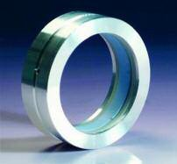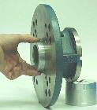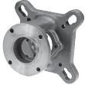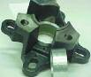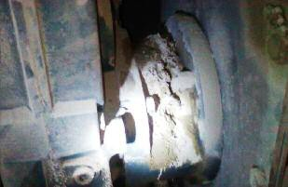Stop Powder Leaks in a Cinch...
...With CinchSeal®!
使用辛驰密封......立即停止粉末泄漏！
Leaking Adapter适配器泄漏

CinchSeal® has a seal design to accommodate the screw conveyor direct drive end. The “Cartridge” seal is designed to replace lip seals and packing on screw conveyor direct drive adapters. The CinchSeal cartridge seal can be easily press fit into your conveyor adapter plate without altering the adapters. Reduce your costly parts and repairs to the drive assembly and stop leaks as well. We have seals that cover the Dodge and Falk part numbers listed below. This seal is also air-purged by drilling and tapping the CEMA adapter housing for standard pipe thread and attaching an air line and regulator. Use the CinchSeal cartridge seal and stop powder leaks.
辛驰密封专门为螺旋输送机直接传动端设计。“集装式”密封用于取代螺旋输送机主动接合器上的唇形密封和填料。辛驰密封集装箱式密封可以轻松地与您的输送机接合板形成压配合，无需更换接合板。减少昂贵的部件和传动装配件维护费用，并避免泄漏。我们的密封适配的道奇和福克零件编号如下所示。可以通过钻孔和轻敲标准管道螺纹的CEMA接合器外壳，对密封进行空气净化，配备空气管路和调节阀。使用集装箱式辛驰密封，可避免粉末泄漏。

DODGE TXT

道奇TXT SCXT105/TXT1 SCXT205/TXT2 SCXT305/TXT3 SCXT405/TXT4 SCXT505/TXT5 SCXT605/TXT6 SCXT705/TXT7

DODGE TA
道奇TA
TA0107L TA1107H TA2115H TA3203H TA4207H TA5215H TA6307H TA7315H
FALK SIZE:
福克规格：

4107 & 5107
4115 & 5115
4203 & 5203
4207 & 5207
4307 & 5307
4315 & 5315
4407 & 5407
4415 & 5415
4507 & 5507
4608 & 5608

CinchSeal • 731 Hylton Road • Pennsauken, NJ • 08110 856.662.5162 • 856.662.5264 • www.cinchseal.com
辛驰密封• 新泽西州彭索肯郡市 • 希尔顿路731号 • 08110
856.662.5162 • 856.662.5264 • www.cinchseal.com

