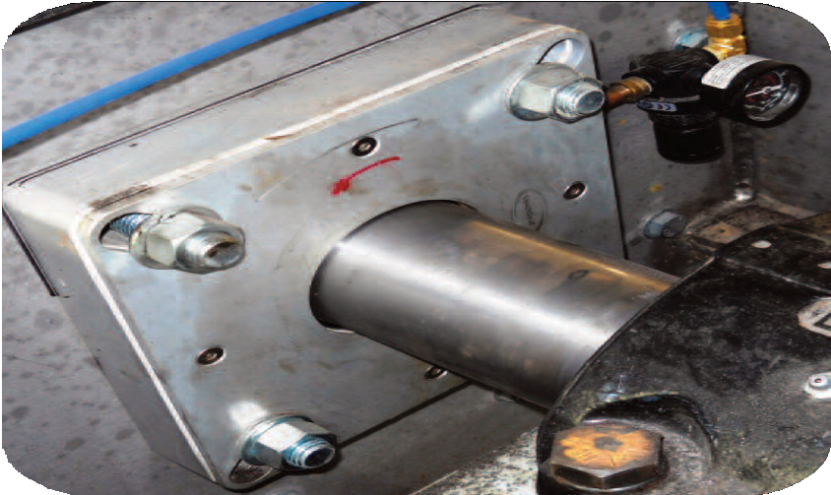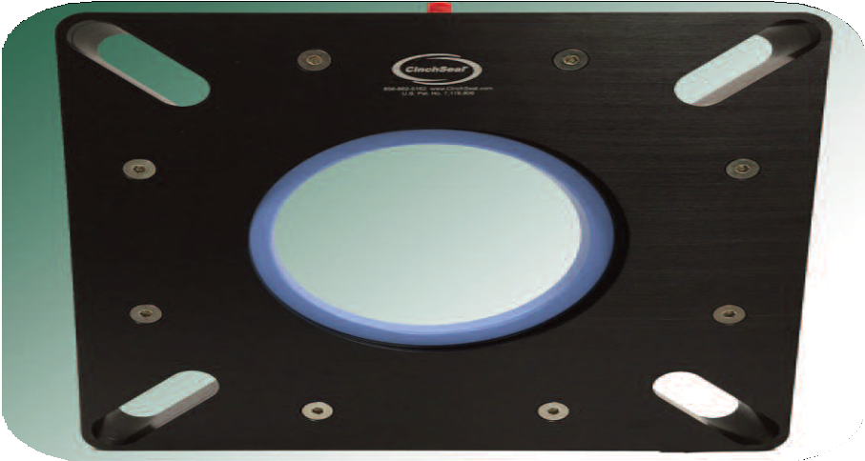7620 & 7650
Solid CinchSeal
美国辛驰密封
7620 & 7650固体密封

- Designed for screw conveyors and other bulk handling equipment ranging from 3.937” to 6.00”
- 专为轴径从3.937”到6.00”的螺旋输送机及其他散装物料输送设备设计
- Temperature ranges -50F to 400F
- 工作温度范围为-50F到400F
- Designed to accommodate repair kits
- 设计可适应维修包
- Bolting pattern will accommodate flange mounted bearings
- 螺栓安装可适应法兰安装轴承座
- The housing is machined out of Anodized Aluminum
- 外壳由阳极氧化铝加工而成
- Designed to handle linear shaft growth, and 1/4” total radial shaft runout
- 设计可承受线性轴增长和1/4”总径向跳动
- Purge with air, 5 to 8 psi above vessel pressure, or silicone grease.
- 通入高于设备内部压力5至8 psi的空气净化，或使用硅脂清洗
- Zero maintenance due to unique self adjusting design
- 独特的自调整设计实现零维护
The maintenance free 7620 and 7650 solid aluminum CinchSeal’s are designed for larger shaft sizes ranging from 3.937” up to 6.00”. They are ideal for screw con- veyors, bucket elevators, and other bulk handling equipment.
辛驰密封7620和7650型号是由固体铝制成的免维护密封，专为从3.937”到6.00”不等的较大轴径设计。适用于螺旋输送机、斗式提升机和其他散装物料输送设备。
The 7620 model has a solid clear coat aluminum housing and endplate with solid hard coat anodized aluminum rotor cups and solid PTFE stator plates. The re- pair kits for the 7620 model are solid.
7620型采用实心透明涂层铝外壳和端板，实心硬质涂层阳极氧化铝转子杯和实心PTFE定子片。7620型配备实心维修包。
The 7650 model has a solid hard coat anodized aluminum housing and end- plate but the internal parts of this model are split to make future repairs possible without having to unbolt the housing.
Future repair kits will consist of split PTFE rotor cups and split elastomer.

7650型号采用实心硬涂层阳极氧化铝外壳和端板，但该型号的内部部件是剖分式的，使日后维修时无需拆除外壳。维修包包括剖分式PTFE转子杯和剖分式弹性体。

CinchSeal • 731 Hylton Road • Pennsauken, NJ • 08110 856.662.5162 • 856.662.5264 • www.cinchseal.com
辛驰密封• 新泽西州彭索肯郡市 • 希尔顿路731号 • 08110
856.662.5162 • 856.662.5264 • www.cinchseal.com

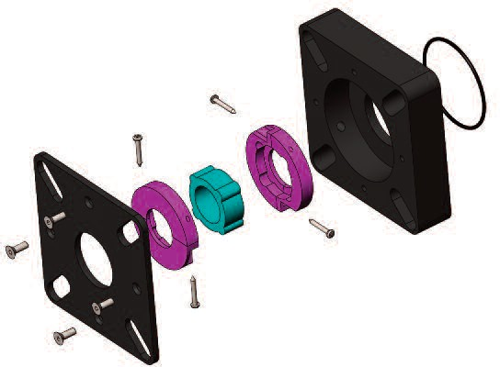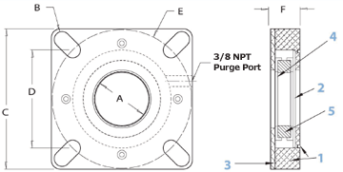

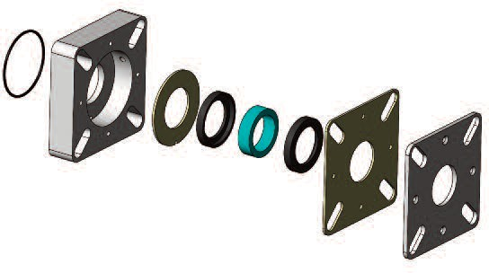O’ringO形环
7620 Assembly
7620部件图
Outboard Stator
外定子
Solid Rotor Cups
实心转子杯
7650 Assembly
Hard Coat Aluminum Housing
硬涂层铝外壳
7650部件图
Split PTFE Rotor Cups
剖分式PTFE转子杯

Elastomer Boot
弹性体防尘套
Inner Stator
内定子

Elastomer Boot
弹性体防尘套

O’ring
O形环

Aluminum Housing铝外壳
Aluminum Outboard Plate
铝外板

Hard Coat Aluminum Outboard Plate
硬涂层铝外板

Available Accessories配件
- Seal Repair Kits密封维修包
- Air Pressure Regulators空气调节阀

B E F

1/8 NPT
Purge Port plug
D
C

3

- Housing - O’ring at Inboard外壳-外部O形环
- Inner Stator内定子
- Outboard Plate外板
- Rotor Cup转子杯
- Elastomer Boot - FDA Approved弹性体防尘套-PDA批准
DIMENSIONAL CHART尺寸图表
F
E
max
最小
E
min
最小
D
min
最小
D
max
最小
A B C
12.518 1.75
3.937 .810 10.00 6.125 8.852 8.662
12.517 1.75
4.437 .810 10.00 6.125 8.851 8.662
Confidential, U.S. Pat. No. 7,178,806. These drawings and specifications are the property of CinchSeal, LLC. Not to be released, or used for any manufacturing or sales withoutwritten permission. Other sizes and metric available.
机密，美国专利7,178,806号。图纸和规格均为辛驰密封有限公司的财产。未经书面许可，不得发布或用于任何生产或销售用途。提供其他尺寸和度量标准。

How the 7620 & 7650 Series Works
7620&7650系列的工作原理
The key component in the both the 7620 and 7650 seal is the blue elastomer that is molded out of an FDA approved silicon material that is very durable and can handle temperatures up to 400F. The elastomer is molded slightly smaller than the shaft size so that an interference fit with the shaft is achieved. This snug fit seals the shaft and stops mate- rial from leaking out as well as causing the internal seal parts to turn with the shaft. Unlike mechanical packing and lip seals that are station- ary and damage rotating shafts, our elastomer spins with the shaft thus eliminating any chance of shaft wear and damage. As the elastomer turns with the shaft it drives two rotating faces that we call “rotor cups” that are compressed with optimum load against stationary faces to seal the potential leak paths. We offer both the 7620 model with solid in- ternals and the 7650 model with split internals that is designed to be repaired with a split repair kit.
4
5
2
7620和7650密封的关键部件均为蓝色弹性体，由美国食品及药物管理局批准的硅胶制成，非常耐用，可承受高达400°F的温度。弹性体的模制尺寸略小于轴的尺寸，与轴过盈配合。这种紧密配合不但对轴起到密封作用，防止原料泄漏，而且使内部密封组件随轴一起旋转。不像机械填料和唇形密封是固定的，会损坏旋转轴，我们的弹性体随轴旋转，从而消除轴磨损和损坏的可能性。当弹性体随轴旋转时，它会带动两个旋转面旋转，我们称之为“转子杯”，它们以最佳负载压在固定面上，对潜在的泄漏路径进行密封。我们提供的7620型号是固定内部结构，7650型号是剖分式内部结构，旨在利用剖分式维修包进行维修。
1

7620 Model
7620型
In the 7620 model, the internal sealing parts are solid and the seal must be unbolted and slide off an empty shaft to be rebuilt. The rotor cups are made out of aluminum that we then hard coat anodize to make the surface harder, and they turn against stationary faces which
we call stator plates. This rotating face against a stationary face creates the primary seal. The PTFE stator plates are the sacrificial part of the seal, and when a repair kit is eventually needed, it would consist of a new solid elastomer and two new PTFE stator plates and the seal is like brand new again.
7620型号采用实心内部密封部件，必须拆除密封并从空轴拿下来才能重新组装。转子杯是由硬涂层铝制成的，表面比较坚硬，它们位于我们称之为定子片的固定面的相反面。旋转面与固定面相对而立，从而形成主密封。PTFE定子片是密封的牺牲部件，维修包包括一个新的固定弹性体和两个新的PTFE定子片，使用维修包重装后，密封会变得焕然一新。
7650 Model
7650型
In the 7650 model, the aluminum housing and endplate are solid but the internal sealing parts are split so that the seal can be repaired without having to unbolt the seal housing. This is the perfect scenario if you have a pillow block bearing arrangement and don’t want to remove the bearing, gear box, or drive motor to rebuild the seal. The split “rotor cups” are made out of of a mineral filled PTFE, and they are now the sac- rificial part of the seal. The 7650 repair kit consists of a new split elastomer and two split PTFE rotor cups.
7650型号采用实心铝壳和端板，但内部密封部件是剖分式的，这样无需拆除密封壳，就可以维护密封。如果你有一个枕式轴承装置，且不想拆开轴承、齿轮箱或驱动电机后重组密封，该型号可提供完美的方案。剖分式“转子杯”是由矿物填充PTFE制成的，它们是密封的牺牲部件。7650型号维修包包括一个新的剖分式弹性体和两个剖分式PTFE转子杯。

The 7620 and 7650 are considered air purged shaft seals that perform best when purged with continuous air pressure set at 5 to 8 PSI over internal vessel pressure. The air purge improves the seal life of the in- ternal parts by creating a higher pressure inside the seal which creates a natural air barrier that keeps product out of the seal and inside the equipment. Air also keeps the rotating seal faces cooler, and it adds closing force to the seal faces as they wear from use so product can’t leak by.
7620和7650是空气净化轴封，当连续连续气压比容器内部压力高5到8PSI时，能发挥最佳性能。空气净化在密封内部产生更高的压力，形成一个自然的气密层，使产品无法进入密封和设备内部，从而提高内部部件的密封寿命。空气还能降低旋转密封面的温度，增加密封面磨损时的闭合力，使产品不会泄漏。
The 7620 and 7650 are available in shafts sizes ranging from 3.937” up to 6.00” and are both repairable.

7620和7650型号的轴径从3.937”到6.00”不等，均可维修。

