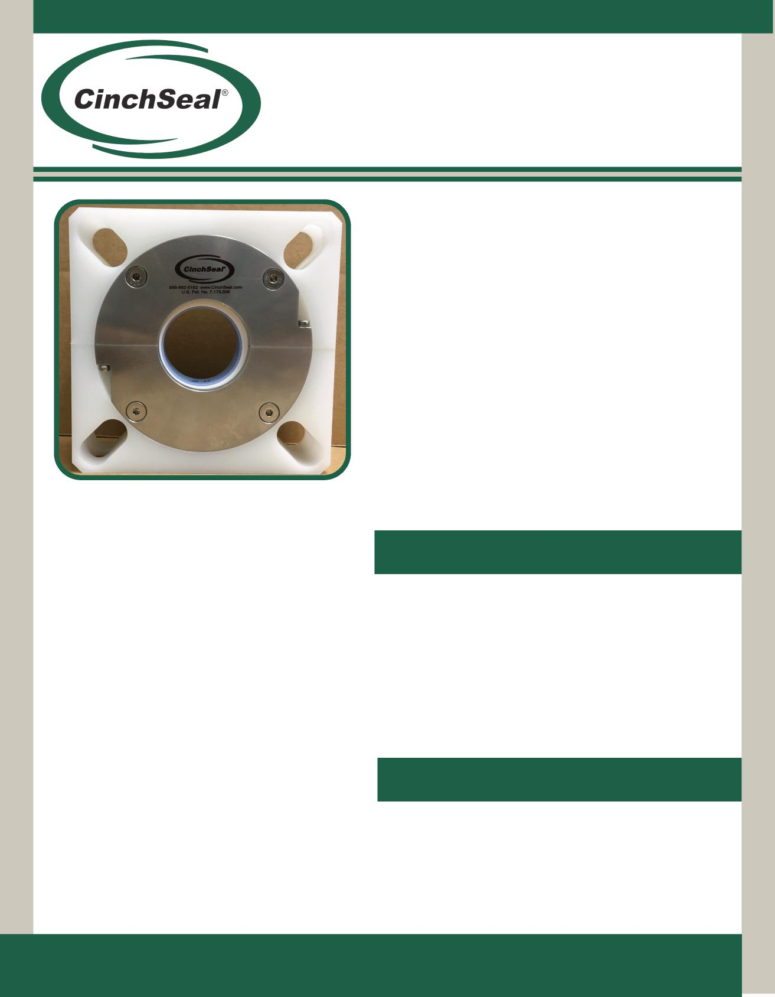
Poly Split (PS) Shaft Seal
Machined entirely split to make
installation a Cinch...
The model PS CinchSeal® is designed to seal screw conveyors, mixing and blending equipment. It is manufactured out of polypoplene and stainless steel to handle dry powder and slurry products in the food service, pharmaceutical and chemical industries where stainless steel is required.
Applications
- Eliminates product leakage, house keeping issues, bearing and drive failure
- Installation requires no equipment removal
- Shaft damage and wear is totally eliminated due to the unique elastomer design that turns with the shaft
The PS CinchSeal is proven effective in sealing ribbon blenders, driers, and paddle mixers used in processing dry powder, semi-solid and slurry applications. Among the particularly challenging materials we have been successful in sealing are: cement, spices, cocoa powder, liquid chocolate, plastics and resins, salt, sugar, etc.
- Eliminates product contamination caused by the breaking down of braided packing
- Seals hazardous vapors and dust
- Consumes less power than braided packing
- Will not damage or undercut shaft
- Seal Repair Kits
- Air Pressure Regulators
- Additional Elastomers
Available Accessories
CinchSeal • 23b Roland Avenue • Mount Laurel, NJ • 08054 856.662.5162 • 856.662.5264 • www.cinchseal.com

Exploded view of CinchSeal Poly Split
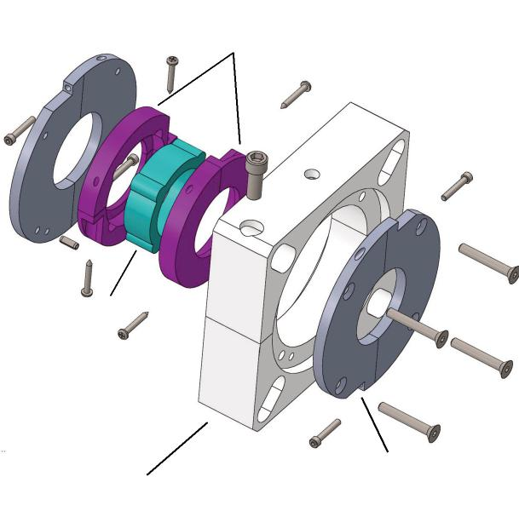
Elastomer Boot
Split Poly Housing
Split PTFE Rotor Cups
Stainless Plate
Installation
How the Poly Split Works
The heart of the PS CinchSeal is the FDA approved elastomer which is designed to create an interference fit on the shaft. This tight fit allows the elastomer to turn with the shaft and thereby eliminating shaft damage or wear. The elastomer seals the shaft and stops product from migrating past while also turning a set of mineral filled PTFE rotor cups. As the elastomer and rotor cups turn with the shaft they are compressed with the optimum amount of face pressure against a stationary face. The rotating face against a stationary face is what creates the primary seal that stops product from getting by. The PTFE rotor cups are designed to be the wearable part of the seal and repair kits are available. The repair kit consists of two new PTFE split rotor cups and new split elastomer. The seal is designed to be purged with air 5 to 8 PSI over vessel pressure to keep rotating seal faces cool and free of material. The PS seal is easy to take apart, clean, and re-assemble for daily maintenance.

The PS CinchSeal should not be installed on severely worn equipment. Damaged shafts or excessive float or misalignment should be corrected prior to installation. The seal must be mounted square to the shaft. Please refer to installation guide when mounting your seal. Call or visit our website if help is needed.
Purge Options
All CinchSeals should be purged with either plant air, nitrogen, or silicone grease. For best results, each seal should have an individual air regulator and not share. Air purging the seal creates a higher pressure inside the seal cavity which creates an air barrier that helps keep material inside the tank and out of the seal which adds to the life of the wearable parts of the seal.
Poly Split Assembly Drawing
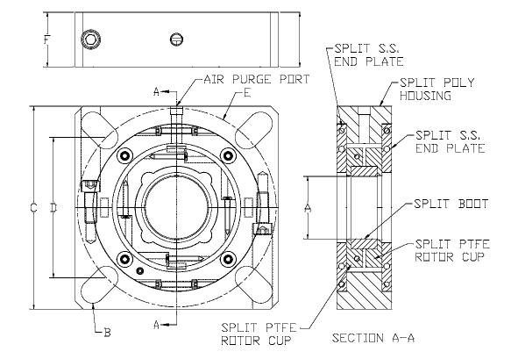
Dimensional Chart
A | B | C | D  min | D  max | E  min | E  max | F
1.5 | .625 | 5.375 | 3.30 | 4.375 | 4.709 | 6.162 | 1.75
2.0 | .750 | 6.50 | 4.0 | 5.386 | 6.657 | 7.618 | 1.75
2.437 | .750 | 7.375 | 4.5 | 6.26 | 6.364 | 8.856 | 1.75
3.0 | .875 | 7.875 | 5.50 | 6.677 | 7.778 | 9.443 | 1.75
3.437 | .875 | 9.25 | 6.76 | 8.052 | 9.560 | 11.387 | 1.75

Confidential, U.S. Pat. No. 7,178,806. These drawings and specifications are the property of CinchSeal, LLC. Not to be released, or used for any manufacturing or sales without written permission. Other sizes and metric available.

